***“Heaven’s Light is Our Guide”***



**Department of Computer Science & Engineering**

**RAJSHAHI UNIVERSITY OF ENGINEERING & TECHNOLOG**

**Lab Report**

|  |
| --- |
| **Submitted By:**  **Name: Khandoker Sefayet Alam**  **Roll:2003121**  **Department: Computer Science & Engineering**  **Section-C**    **Course code: CSE 3102**  **Course name: Database Management System** |

|  |
| --- |
| **Submitted To:**  **Barshon Sen** |

❖Query 1.1: Display the name and IMDb rating of all the movies according to

their IMDB rating (in descending order); if multiple movies have the same

IMDB rating then rearrange those movies alphabetically according to their

names.  
code:

SELECT Movie_name,IMDB_Rating FROM movie ORDER BY IMDB_Rating DESC, Movie_name ASC

table:



❖Query 1.2: Find the total number of movies in the database.

code:  
SELECT COUNT(Movie_ID) FROM movie

table:



❖ Query 1.3: Find how many movie-genres are there in the database.

code:

SELECT COUNT(DISTINCT Genre) FROM movie

table:

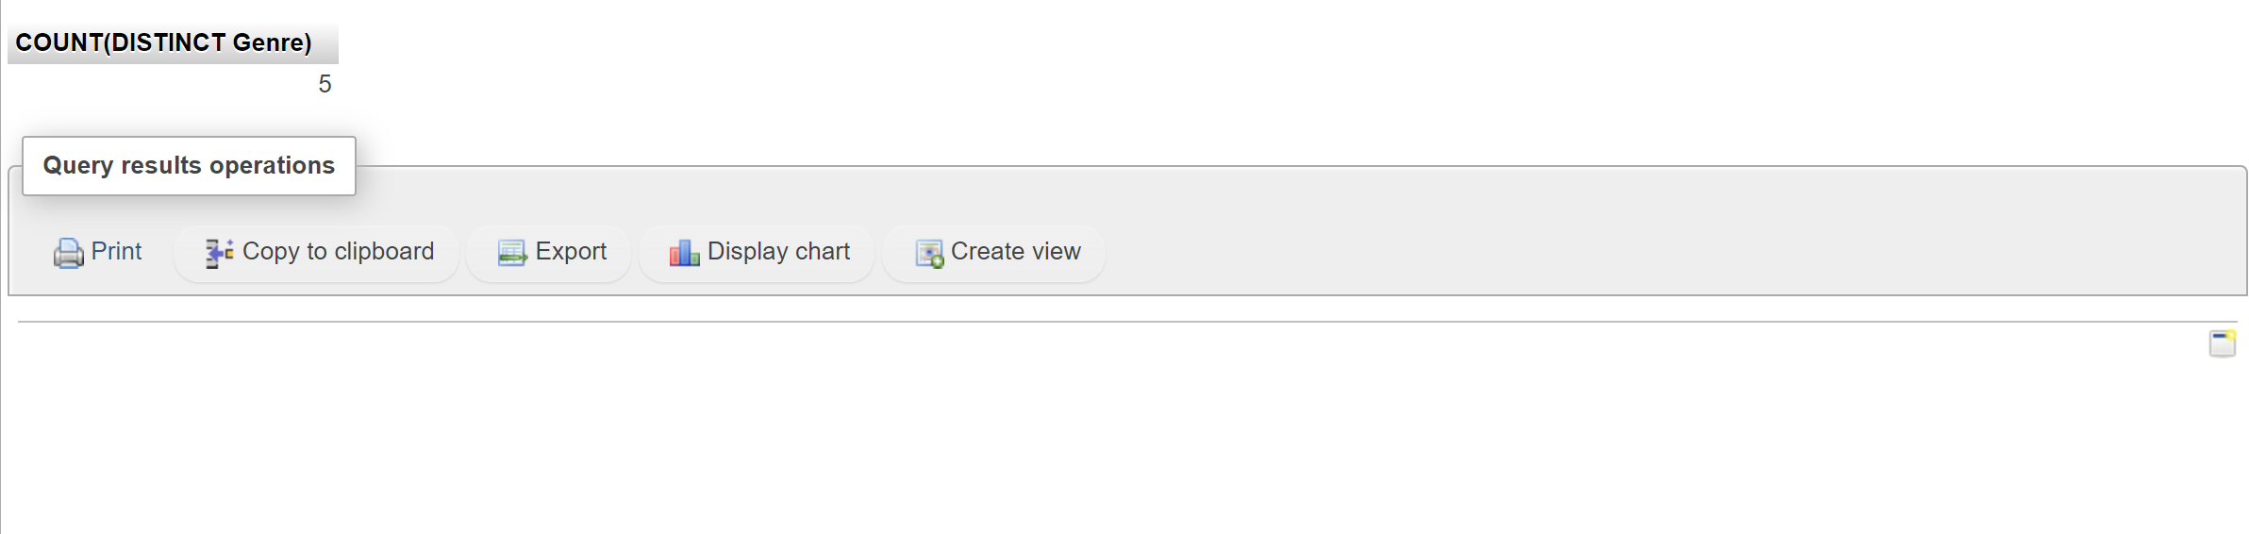

❖ Query 1.4: Find the average IMDB rating of the movies of the drama genre.

code:

SELECT AVG(IMDB_Rating) FROM movie Where genre=’Drama’

table:

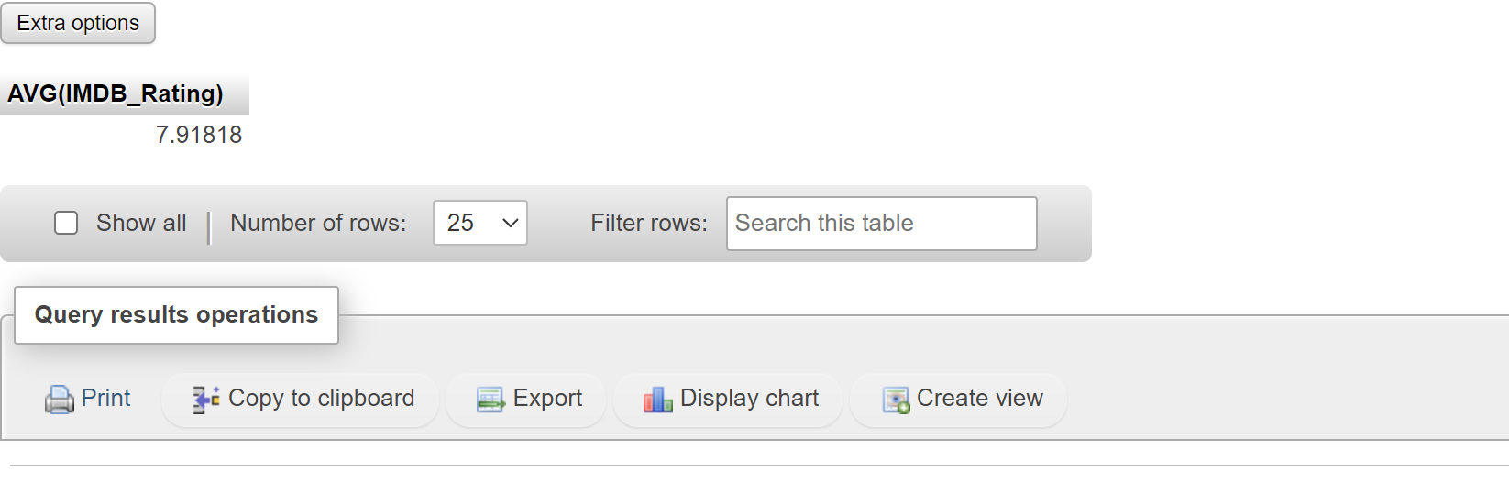

❖ Query 1.5: Find the total number of movies in each genre.

code:  
SELECT COUNT(Movie_ID) as Frequency,Genre FROM movie GROUP BY Genre

table:

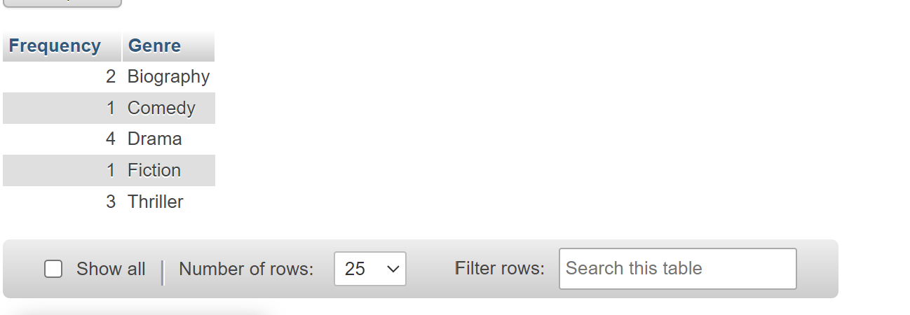

Level # 2

❖ Query 2.1: Find the number of movies directed by a director on average.

code:

SELECT AVG(No_of_film) FROM director

table:

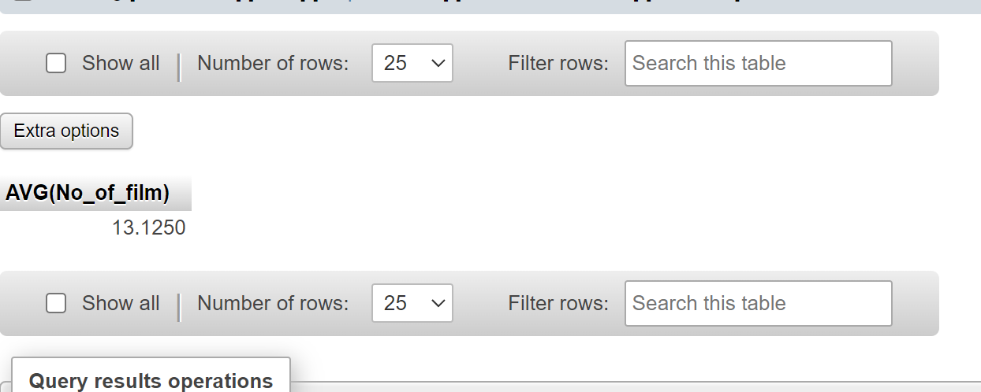

❖ Query 2.2: Find the name, genre, IMDb rating and the name of the director

of all the movies directed by Satyajit Ray, Zahir Raihan, Rituparno Ghosh

and Kaushik Ganguly.

code:

SELECT movie_name,genre,IMDB_Rating,director.Director_name FROM movie LEFT JOIN director ON movie.Director_ID=director.Person_Id WHERE director.Director_name IN ("Satyajit Ray","Zahir Raihan","Rituparno Ghosh","Kaushik Ganguly")

table:

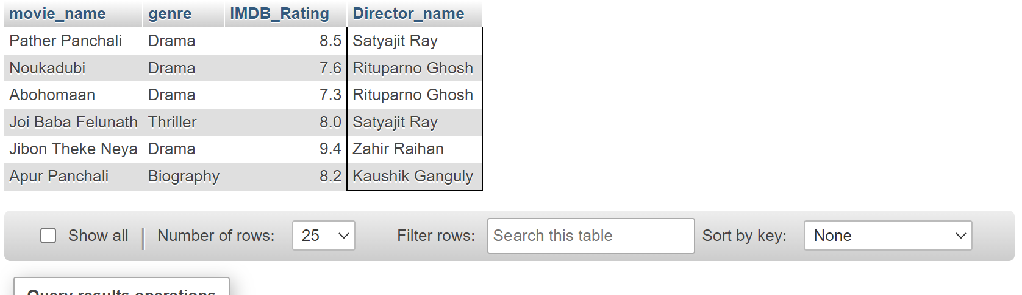

❖ Query 2.3: Find the name and current age of all the directors and actors.

code:

SELECT Actor_name As Name,Year(Now())-Birth_Year As Age FROM actor

UNION

SELECT Director_name As Name,Year(Now())-Birth_Year As AGE FROM director

table:

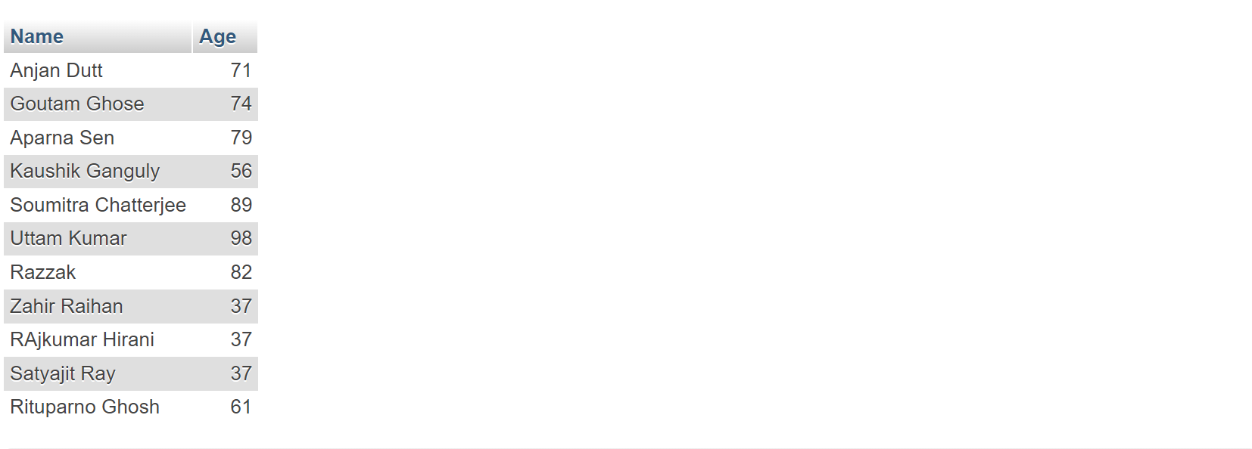

❖ Query 2.4: Find the name, current age, number of films as an actor and

number of films as a director of those actors who directed at least one film.

code:

SELECT actor.Actor_Name as Name,Year(Now())-actor.Birth_Year As Age,actor.No_Of_Film As Movie_acted ,director.No_of_Film As Movie_directed FROM actor INNER JOIN director ON actor.Actor_Name=director.Director_name

table:

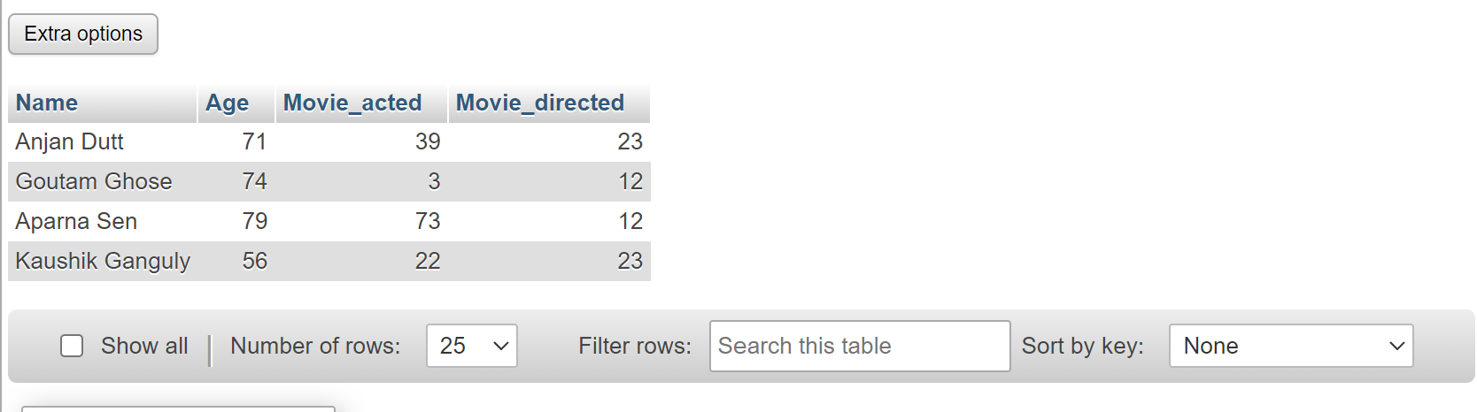

❖ Query 2.5: Consider that there is no No_of_Films attribute in the Director

relation. Now find the name of all the directors and number of movies

directed by each director.

code:

SELECT COUNT(movie_ID) As No_of_movies,director.Director_name FROM movie JOIN director ON director.Person_Id=movie.Director_ID

GROUP BY Director_ID

table:

